Web Service

Definition
# Source: AI Source: Provided by: [Data Path: Persons Table -> ID Column: 1, Name_En Column: Motasem Essam] -> From: [ChatGPT] on [1/19/2026]
A web service is a system that allows different applications to communicate and exchange data over the internet.
A Web Service is a specific kind of Web API that strictly follows web service standards. •

Simple Definition
# Source: AI Source: Provided by: [Data Path: Persons Table -> ID Column: 1, Name_En Column: Motasem Essam] -> From: [ChatGPT] on [1/19/2026]
👉 Web service = a way for applications to talk to each other online

How It Works
# Source: AI Source: Provided by: [Data Path: Persons Table -> ID Column: 1, Name_En Column: Motasem Essam] -> From: [ChatGPT] on [1/19/2026]
- One application sends a request
- The web service processes it
- It sends back a response (data)
👉 Communication usually happens using formats like JSON or XML

Types of Web Services
# Source: AI Source: Provided by: [Data Path: Persons Table -> ID Column: 1, Name_En Column: Motasem Essam] -> From: [ChatGPT] on [1/19/2026]
• SOAP Web Services (Simple Object Access Protocol) – a protocol-based web service that uses XML and follows strict rules for communication
• RESTful Web Services (Representational State Transfer) – lightweight web services that use HTTP methods (GET, POST, PUT, DELETE) and typically use JSON
• XML-RPC Web Services – web services that use XML to encode requests and responses and allow remote procedure calls
• JSON-RPC Web Services – similar to XML-RPC but uses JSON format for faster and simpler communication
• GraphQL Web Services – a modern type that allows clients to request exactly the data they need from a single endpoint
• REST-like / Hybrid Web Services – services that combine features of REST with other approaches for flexibility

Key Features
# Source: AI Source: Provided by: [Data Path: Persons Table -> ID Column: 1, Name_En Column: Motasem Essam] -> From: [ChatGPT] on [1/19/2026]
- Works over the internet (HTTP/HTTPS)
- Enables data exchange between systems
- Platform-independent (works across different technologies)
- Uses standard formats like JSON and XML

Examples of Web Services
# Source: AI Source: Provided by: [Data Path: Persons Table -> ID Column: 1, Name_En Column: Motasem Essam] -> From: [ChatGPT] on [1/19/2026]
- Weather service → provides weather data
- Payment service → processes online payments
- Map service → provides location and directions

Advantages
# Source: AI Source: Provided by: [Data Path: Persons Table -> ID Column: 1, Name_En Column: Motasem Essam] -> From: [ChatGPT] on [1/19/2026]
- ✅ Allows integration between different systems
- ✅ Reusable and scalable
- ✅ Works across platforms and languages
- ✅ Supports automation and data sharing

Disadvantages
# Source: AI Source: Provided by: [Data Path: Persons Table -> ID Column: 1, Name_En Column: Motasem Essam] -> From: [ChatGPT] on [1/19/2026]
- ❌ Requires internet connection
- ❌ Can have security risks if not protected
- ❌ May be slower due to network communication
- ❌ Depends on external services availability

Web Service VS API

1. API (Application Programming Interface)
# Source: AI Source: Provided by: [Data Path: Persons Table -> ID Column: 1, Name_En Column: Motasem Essam] -> From: [ChatGPT] on [1/19/2026]
- An API is any set of rules that allows one program to communicate with another.
- It doesn’t have to be on the web—it can be a library API, OS API, or even a local program interface.
- Example: libcurl functions, Windows File API, JavaScript fetch().

2. Web Service
# Source: AI Source: Provided by: [Data Path: Persons Table -> ID Column: 1, Name_En Column: Motasem Essam] -> From: [ChatGPT] on [1/19/2026]
- A Web Service is a specific type of API that is accessible over the web (HTTP/HTTPS).
- It exposes endpoints that clients can call over a network.
- Usually returns structured data like JSON or XML.
Key point:
- All Web Services are APIs, but not all APIs are Web Services.
  - Web Service → subset of APIs (network-based).
  - API → can be anything, including local libraries or OS interfaces.

Examples:
# Source: AI Source: Provided by: [Data Path: Persons Table -> ID Column: 1, Name_En Column: Motasem Essam] -> From: [ChatGPT] on [1/19/2026]
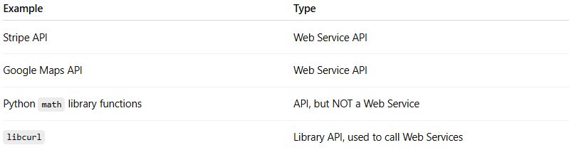
Example | Type
Stripe API | Web Service API
Google Maps API | Web Service API
Python math library functions | API, but NOT a Web Service
libcurl | Library API, used to call Web Services

💡 Memory trick:
# Source: AI Source: Provided by: [Data Path: Persons Table -> ID Column: 1, Name_En Column: Motasem Essam] -> From: [ChatGPT] on [1/19/2026]
Think of it like this: API = broad category | Web Service = API over the web

Web Services VS Web APIs

1. Web API
# Source: AI Source: Provided by: [Data Path: Persons Table -> ID Column: 1, Name_En Column: Motasem Essam] -> From: [ChatGPT] on [1/19/2026]
- A Web API is any API that can be accessed over the web using HTTP/HTTPS.
- It can use any protocol, not necessarily SOAP or XML — usually JSON/REST, sometimes GraphQL.
- Example: RESTful APIs like the GitHub API, or even APIs accessed via fetch() in JavaScript.
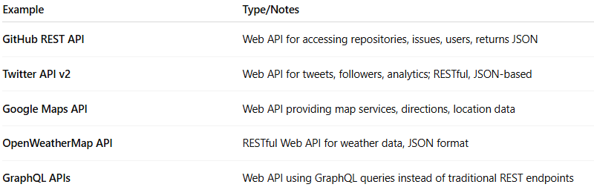
Example | Type/Notes
GitHub REST API | Web API for accessing repositories, issues, users, returns JSON
Twitter API v2 | Web API for tweets, followers, analytics; RESTful, JSON-based
Google Maps API | Web API providing map services, directions, location data
OpenWeatherMap API | RESTful Web API for weather data, JSON format
GraphQL APIs | Web API using GraphQL queries instead of traditional REST endpoints

2. Web Service
# Source: AI Source: Provided by: [Data Path: Persons Table -> ID Column: 1, Name_En Column: Motasem Essam] -> From: [ChatGPT] on [1/19/2026]
- A Web Service is a specific kind of Web API that strictly follows web service standards.
- Traditional Web Services often use SOAP (XML-based) or WSDL, but modern Web Services can also be RESTful.
- Example: SOAP-based currency conversion service or older SOAP banking services.
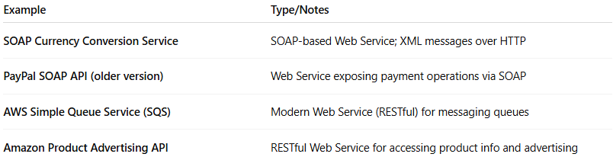
Example | Type/Notes
SOAP Currency Conversion Service | SOAP-based Web Service; XML messages over HTTP
PayPal SOAP API (older version) | Web Service exposing payment operations via SOAP
AWS Simple Queue Service (SQS) | Modern Web Service (RESTful) for messaging queues
Amazon Product Advertising API | RESTful Web Service for accessing product info and advertising

✅ Key Difference
# Source: AI Source: Provided by: [Data Path: Persons Table -> ID Column: 1, Name_En Column: Motasem Essam] -> From: [ChatGPT] on [1/19/2026]
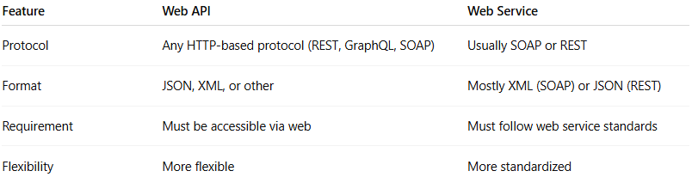
Feature | Web API | Web Service
Protocol | Any HTTP-based protocol (REST, GraphQL, SOAP) | Usually SOAP or REST
Format | JSON, XML, or other | Mostly XML (SOAP) or JSON (REST)
Requirement | Must be accessible via web | Must follow web service standards
Flexibility | More flexible | More standardized

In short:
# Source: AI Source: Provided by: [Data Path: Persons Table -> ID Column: 1, Name_En Column: Motasem Essam] -> From: [ChatGPT] on [1/19/2026]
- All Web Services are Web APIs, but not all Web APIs are Web Services, Web APIs include a broader category like REST or GraphQL APIs that don’t strictly follow SOAP/WSDL standards.
- Modern REST APIs are often called both Web APIs and Web Services.
- In practice today, most modern APIs (like GitHub or Twitter) are both Web APIs and Web Services in the loose sense.

Web Service vs Web App
# Source: AI Source: Provided by: [Data Path: Persons Table -> ID Column: 1, Name_En Column: Motasem Essam] -> From: [ChatGPT] on [1/19/2026]
- Web App → used by humans (user interface)
- Web Service → used by applications (no direct UI)

Simple Example
# Source: AI Source: Provided by: [Data Path: Persons Table -> ID Column: 1, Name_En Column: Motasem Essam] -> From: [ChatGPT] on [1/19/2026]
- A mobile app asks a server for weather data
- The server sends back temperature and forecast
👉 That interaction is a web service

Simple Analogy
# Source: AI Source: Provided by: [Data Path: Persons Table -> ID Column: 1, Name_En Column: Motasem Essam] -> From: [ChatGPT] on [1/19/2026]
Think of a web service like a waiter in a restaurant:
- You (app) order food (request)
- Waiter takes it to the kitchen (server)
- Brings back your food (response)

Summary
# Source: AI Source: Provided by: [Data Path: Persons Table -> ID Column: 1, Name_En Column: Motasem Essam] -> From: [ChatGPT] on [1/19/2026]
👉 Web service = a system that enables communication and data exchange between applications over the internet

